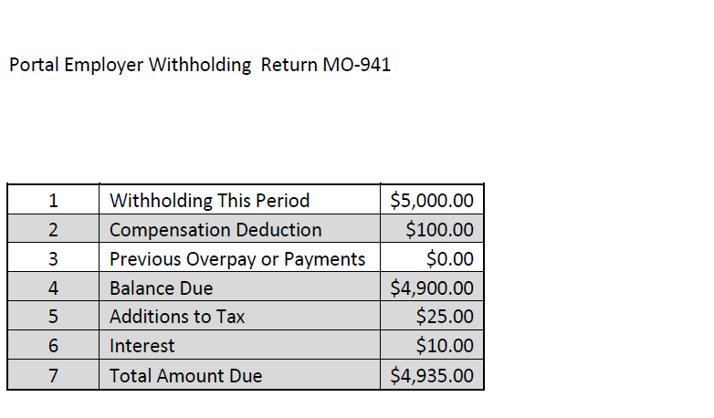

Instructions for each line number
1- Withholding This Period - Enter the amount of employer tax withheld for the period. If there was no withholding during the reporting period enter zero.
2- Compensation Deduction - The employer withholding compensation deduction is calculated for you. The calculated amount is determined by the annual accumulated total of withholding reported to the Department. For information regarding how compensation is calculated see http://dor.mo.gov/faq/business/withhold.php#general
3- Previous Overpay/Payments - Enter amount of previous payments or credits.
4- Balance Due - This amount is be calculated for you and equals the sum of Line 1 less Lines 2 and 3.
5- Additions to Tax - This amount is calculated for you if your return is completed after the due date.
6- Interest - This amount is calculated for you if your return is completed after the due date.
7- Total Due - This amount is calculated for you and equals the sum of Lines 4, 5 and 6.
Final Return-If this is your final return, mark the final return box, enter the close date and check the reason for closing your account.

